**Foraging, fear and behavioural plasticity, a lesson from hummingbirds**

**Abstract**

Increasing number of studies demonstrates a high variation in foraging behaviour that is hard to explain solely based on risk allocation hypothesis (i.e. food**–** and predation–based arguments only). One of potential mechanisms that may account for this variation is fitness consequences of various behaviours associated with foraging that vary across the context. Here, we explored this mechanism using the context of a trade-off between food resource exploitation and risk avoidance, always present in the long-billed hermit hummingbird (LBH, *Phaethornis longirostris*) due to its extreme energy demands and predation vulnerability. We quantified birds foraging efficiency in regards to three behaviours: a) exploration (number of feeders used during the foraging visit), b) risk avoidance (initial latency to approach the feeder to forage) and c) arousal (amount of movements during the foraging visit) in conditions of two different levels of perceived predation risk (low – control, and high – experimental, with a threatening ant model). We found that foraging efficiency decreased in response to threatening conditions. However, behavioural performance of individuals in regard to exploration, risk-avoidance and arousal additionally affected the foraging efficiency in a condition-dependent manner. More exploratory individuals had also higher foraging efficiency in control conditions, though a reversed pattern was observed when exposed to a threat (experimental setting). Regardless of conditions, arousal was positively associated with foraging efficiency while risk-avoidance was negatively related to foraging efficiency. Importantly, exploratory behaviour and risk-avoidance were quite repeatable behaviours suggesting that they may be related to intrinsic differences between individuals. All these results together highlight the importance of behavioural variability in shaping evolution of foraging strategy.

**Keywords**

risk allocation hypothesis, predator, prey, risk-avoidance, exploratory behaviour, arousal, repeatability

**Introduction**

It is now widely accepted that animal’s foraging strategy (i.e. resource exploitation) depends not only on the amount and distribution of available food resources (Herborn, Heidinger, Alexander, & Arnold, 2014; Morrison, Raplph, Verner, & Jehl, 1990), and animal motivation (both in the sense of marginal value theorem (Charnov, 1976) and/or body condition (Bautista, Tinbergen, & Kacelnik, 2001)) but also on predation pressure (Lima & Bednekoff, 1999). The intensity of a prey vigilance increases with the level of risk predation (probability of predator presence), affecting its foraging efficiency. As the risk allocation hypothesis (RAH) imposes, a prey allocates time for foraging inversely proportionately to predation pressure (Lima & Bednekoff, 1999; Verdolin, 2006). Thus, in a given food-resources–predation landscape, a fixed foraging strategy is expected to evolve (Krebs, 1980). However, increasing number of studies demonstrates a high variation in foraging strategies (Camprasse, Cherel, Bustamante, Arnould, & Bost, 2017; Moldoff & Westneat, 2017; Patrick et al., 2014), which is hard to explain using only food- and predation-based arguments (Bautista et al., 2001).

Animal behavioural plasticity is an important source of variation in performance of any strategy, including foraging decisions (Alonzo, 2015; Bell, Hankison, & Laskowski, 2009; Dingemanse, Kazem, Reale, & Wright, 2009; Herborn et al., 2014; Nussey, Wilson, & Brommer, 2007; Toscano, Gownaris, & Heerhartz, 2016). Existing evidence demonstrates not only the variation *per se* but consistent inter-individual differences in average level of behaviour displayed across a range of contexts (Carere and Maestripieri 2013) and in responsiveness to environmental variation (Nussey et al. 2007; Dingemanse et al. 2009). Within a species/population, individuals usually represent a full continuum of a given behavioural display, with two polar-opposite phenotypes (e.g. high and low exploratory behaviour) and various intermediate forms in between. Importantly, fitness advantages of the contrasting behaviours may differ in various contexts, sometimes dramatically (Smith & Blumstein, 2008). For example, highly exploratory behaviour can be advantageous in conditions of resource competition but disadvantageous in in a higher predation pressure environment (Dall, Houston, & McNamara, 2004; Quinn, Cole, Bates, Payne, & Cresswell, 2012a; Réale, Reader, Sol, McDougall, & Dingemanse, 2007; Smith & Blumstein, 2008). Despite growing number of studies showing both directly and indirectly behavioural variability in the performance of various strategies, it is still not well understood how this behavioural variation is maintained in the population.

The fitness pay-offs of a behavior is expected to drive the variation (Dingemanse & Réale, 2005; Moldoff & Westneat, 2017; Smith & Blumstein, 2008). Under viarable conditions, a diversity of behavioral strategies can be mantained when not a single one performes in an optimal way in all contexts. If so, performance may vary as a function of the interactions between social or environmental selective forces, which can help reveal the complex interplay of intrisic and extrinsic factors shaping behavioral variability. Here, we examined the issue in wild ranging, long-billed hermit hummingbirds (LBHs, *Phaethornis longirostris*).

Hummingbirds are known for their extreme metabolism and high need for energy intake that makes them constantly motivated to forage (Suarez, 1992). As such, they are expected to be under strong selection for maximing foraging efficiency. This is particularly significant for traplining foraging species, which use flowers dispersed across the habitat in a route-like fashion, a more unpredictable resource (Araya-Salas, Gonzalez-Gomez, Wojczulanis-Jakubas, López, & Wright, 2018; F. Gary Stiles & Wolf, 1979). On the other hand, such a free foraging foraging entails a period of high vulnerability for hummingbirds, and that is regularly exploited by a wide range of predators (Lorenz, 2007; Nyffeler, Maxwell, & Remsen, 2017; Owen & Cokendolpher, 2006; Sazima, 2015; F. G. Stiles, 1978; Zenzal, Fish, Jones, Ospina, & Moore, 2013), which in turn, results in a trade-off between efficient foraging and predation avoidance in hummingbirds. The differential pay-offs in the selective landscape given by these two factors is expected to shape variabilty in foraging strategies.

We used foraging efficiency as a proxy to assess the pay-offs of diferent behavioral strategies under a trade-off between food resource exploitation and risk avoidance of long-billed hermits. We considered the issue in the context of low and high level of perceived predation risk and in regard to three behavioural axes commonly linked to the explotation of food resources: a) exploration (number of foraging spots used during the foraging visit), b) risk-avoidance (latency to approach the foraging spot to forage), and c) arousal (amount of movements during the foraging event) (Couchoux & Cresswell, 2012; Herborn et al., 2014; Quinn, Cole, Bates, Payne, & Cresswell, 2012b; Réale et al., 2007; Smith & Blumstein, 2008). Overall, we expected that not a single behavioral strategy would provide the highest efficiency across risk levels, and that efficiency under particular risk conditions would be modulated by intrinsic individual behavioral variation.

**Material and methods**

*Fieldwork.* We carried out the study at La Selva Biological Station, Costa Rica (10 o23’ N, 84o10’ W) between May and June 2015. Birds were individually marked with foam tags with unique colour combinations, attached to bird back and chest with nontoxic eyelash glue (Araya-Salas et al. 2018). Of the 21 birds marked at the study lek, 12 individuals regularly visited commercial hummingbird feeders (900 ml, the model: Perky Pet #209B, modified to have a single opening for accessing “nectar”) during the habituation period. These feeders were located at two different sites, each being ca 300 m distant from the lek border.

To examine foraging efficiency of LBHs and quantify their behaviour in low and high risk predation context, we applied a field experiment using a set-up of three feeders (as described above), filled up with ~30% sugar-water and arranged in a line (separated by ca 10 cm distance from each other, Fig. 1 and the videos in Supplementary Materials). The experiment sessions (each lasting 3-4 hours) consisted of two consecutive phases performed at the same day, in the low (first phase) and high risk (second phase) of predation context. All the experiment sessions were conducted in the mornings when the foraging activity peak occurs (F. Gary Stiles & Wolf, 1979). During the whole experiment birds were allowed to forage on the nectar spontaneously and their behaviour was recorded by a commercial camera (continuous recording mode; model: Fujifilm HS30). Only during the second phase, to increase the level of predation risk, we attached to feeders a threat model, a dead specimens of the bullet ant (*Paraponera clavata*; found dead in the forest). Although the ant is not a predator of hummingbirds its presence in flowers deter visitation in several hummingbird species, including the long-billed hermit (author, pers. obs). We performed total of four complete experimental sessions within ca two weeks. An exemplary video clips of the two phases of the experiment, with an individual behaviour is provided in Supplementary Materials (video 1, 2).

*Videos analysis.* We screened the video recordings with VLC software (www.videolan.org), to locate and cut out video fragments with foraging visits of all focal birds. A foraging visit was considered whenever a bird inserted the bill into a feeder at least once. For each bird’s visit we established key time-points (white and black circles on Fig. 1), with 0.1 seconds precision, using Cowlog software (Pastell, 2016). Based on these time-points we calculated the duration of latency to forage, defined as the interval between appearance in the feeder area (usually hovering in front of the feeder) and the onset of foraging (time from *a* to *b* on Fig. 1); duration of feeding interval/s (time from *b* to *c* on Fig. 1; on average 4.9 events, with a range of 1-26); duration of feeding break/s (time from *c* to *d* on Fig. 1); duration of total foraging (time from *b* to *e*, Fig. 1) and duration of total foraging visit (time from *a* to *e* on Fig. 1). For each visit we also noted which and how many times each of the three feeders were used by the focal bird.

To quantify birds movements around the feeders, we took advantage of the line-arrangement of the feeders that greatly restricted birds activity to two directions. That simplified further analyses, as operating in two-dimensional space we could establish Cartesian coordinates of a bird position for each video frame using the software Tracker version 5.1.5 (physlets.org/tracker). Of that we calculated distances between each two bird’s positions using Pythagoras theorem.

*Parameters.* We calculated **foraging efficiency** as the ratio of the total duration of foraging (sum of the duration of all feeding intervals) to the total duration of the foraging visit. To characterize individual differences in foraging (i.e. foraging strategies) we measured three behavioural features that have been linked to intrisic individual characteristics in other species and have been shown to affect foraging: exploration, risk-avoidance and arousal (Couchoux & Cresswell, 2012; Herborn et al., 2014; Quinn et al., 2012b; Réale et al., 2007; Smith & Blumstein, 2008). As a proxy for **exploration** we utilized totalnumber of feeders visited during the foraging visit, divided by the total foraging duration. As a proxy for **risk-avoidance** we used latency to approach the feeder, as defined above (time from *a* to *b* on Fig. 1). For both parameters, the higher the value, the stronger was the exhibited behaviour. As **arousal** we considered the coefficient of variance in spatial distances covered by an individual during the whole foraging visit, divided by the number of visited feeders. The higher value of the standardized coefficient was related to the higher arousal. All behavioural features used to characterize foraging strategies were measured during the low risk treatment.

*Data analysis.* All the analyses were performed in R (R Core Team, 2017). Since all parameters had skewed distribution, we log-transformed them prior analyses (Fig. S1). We estimated the repeatability of foraging efficiency, exploration, risk-avoidance, and arousal (Nakagawa & Schielzeth, 2010), using *rptR* package (Stoffel, Nakagawa, & Schielzeth, 2017). We examined variation in foraging efficiency (response variable) as function of risk level and intrinsic behavioural features [exploration, latency and arousal (predictors)] using a Bayesian generalized linear mixed model with individuals as random factor (to address pseudo-replication; Zuur et al. 2009). We fitted three models representing alternative hypothesis explaining variation in foraging efficiency. The first model represent a more traditional view of foraging behaviour in which efficiency is only affected by the level of risk. The second model included an interaction among intrinsic behavioural traits and risk level, which represents a more nuanced scenario in which the interplay between risk level and inter-individual behavioural differences determines foraging efficiency. There was only little collinearity between predictors (correlation coefficient range from -0.21 to -0.10; Fig. S2). Finally, we also fitted an intercept-only model representing the scenario in which the proposed predictors do not affect efficiency. These three alternative models were compared using model selection based on the deviance information criteria (DIC) (Meyer, 2016). Models were run with single predictor for intrinsic behavioural traits (arousal, exploration and risk avoidance) as well as in a global model with all behavioural predictors included. The two approaches yield qualitatively similar results, therefore we presented here only the outcome of the global model while the outcome of the single behaviour-predictor models are presented in Supplementary Materials, Table S1, Table S2, Fig. S3). Models were fitted using the R package *MCMCglmm* (Hadfield, 2010).

**Ethical note**

All activities (birds marking, feeding, and video recording/observations) were performed with the greatest care. The study was described were reviewed and authorized by Costa Rican Ministerio del Ambiente y Energia (063-2011-SINAC), and performed in accordance with their guidelines and regulations.

**Results**

**Repeatability** of all the parameters was medium to low, significant for all the parameters except for arousal (Fig. 2). The best model analysing birds foraging efficiency included all the behavioural parameters and their interaction with the risk predation context (Table 1). All parameters and their interaction were significant in this model except for the risk avoidance (Table 2). Overall, foraging efficiency was lowered in the high the elevated risk context (Fig. 3) and was affected by birds’ explorative behaviour and arousal. Importantly, the effect of behavioural parameters on the foraging efficiency was context dependent (Table 2). The most dramatic effect was found in exploratory behaviour, which was positively related to foraging efficiency in low risk context but the opposite pattern was observed at higher risk context (Fig. 4). Arousal was positively related to foraging efficiency and this was particularly pronounced when birds faced higher risks (Fig. 4). Risk avoidance tended to lower foraging efficiency and did not differ between risk levels (Fig. 4)

**Discussion**

As we could expect in the light of the risk allocation hypothesis (Lima and Bednekoff 1999) foraging efficiency of the LBH decreased in response to threatening conditions. However, behavioural performance of individuals in regard to exploration, risk-avoidance and arousal additionally affected the foraging efficiency, interestingly in condition-dependent manner. These results suggest that a range instead of a single, fixed strategy should be considered, when modelling the time allocation into foraging in the context of threatening situation. The results also highlight the importance of behavioural variability in shaping evolution of foraging strategy.

Despite not being a specific prey target, hummingbirds may be opportunistically hunted by a wide range of predators (e.g. Owen and Cokendolpher 2006; Lorenz 2007; Zenzal et al. 2013; Sazima 2015; Nyffeler et al. 2017). That imposes a considerable predation risk and favours evolution of risk-avoidance behaviour. Indeed, we found that experimental exposure of an ant, potentially representing just a threat of being bitten (but not eaten), was enough for LBHs to exhibit higher risk-avoidance (longer latency to approach the feeder) and lower movement activity compared to the control conditions. Importantly, despite of the threat, birds did forage although with a lower efficiency. This places LBHs in a group of species representing so call paradox of risk-allocation hypothesis - in conditions of a frequent predator presence, prey might need to forage actively even though predators are present (Lima and Bednekoff 1999; Ferrari et al. 2009). It is worth to evoke in that context one of assumptions of the RAH, which is ‘living on the edge’ in terms of meeting energy demands. This assumption seems to be rarely met in most of animal species used to test the hypothesis so far (Ferrari et al. 2009). Hummingbirds, given their extreme metabolism rate, could be a rare example when the assumption is actually true.

The changes in LBHs behaviour in response to a threat, longer latency and lower arousal, are likely to be adaptive. A longer time spent at the foraging site before the feeding onset may allow an individual to thoroughly evaluate the risk-level and so to make adequate foraging decision. If a threat is not considered mortal, as it was likely to the case in the present study, the individual initiates foraging despite being threaten, otherwise it might search for another food resource or postpone foraging event. Decreased activity (lower arousal) of an individual in the condition of high-risk predation may lower chances of being spotted and so hunted by a predator. Indeed, decreased movement activity is expected in the light of the RAH (Lima & Bednekoff, 1999) with some evidence supporting this prediction (e.g. Sih and McCarthy 2002 but see other examples reviewed in Ferrari et al. 2009). This prediction may not be fully applicable for the LBHs however, as here, the prey was in a full exposure to the threat (i.e. “already spotted by a predator”). Thus an alternative explanation of the lowered arousal in the context of elevated risk could be a cognitive overload associated with the need to evaluate the risk situation, which could, in turn, affect locomotor activity. The exploratory behaviour was similar regardless of circumstances, which may be surprising if to assume that less exploratory behaviour would be expected in threatening conditions for the same reasons as for the arousal (Ferrari, Sih, & Chivers, 2009b). This lack of differences in the exploratory behaviour between control and experimental conditions could be explained in the context of birds personality (see below).

Each of the examined behaviours affected foraging efficiency, and in case of the exploratory behaviour the effect was dependent on the circumstances. In control conditions individuals exhibiting more exploratory behaviour had also overall higher food intake during the foraging visit. Reversed pattern was observed for the experimental conditions. A simple reason of the reversed pattern could be that each time an individual stopped feeding to change feeder it had longer time intervals, probably associated with the need to analyse “*de novo*” the risk situation. The fact, that individuals were consistent over the time and context in their exploration suggests that this behaviour may be related to personality (Dingemanse, Kazem, Wright, & Biologiques, 2010; Dingemanse & Réale, 2005; Montiglio, Sih, Mathot, Wolf, & Dingemanse, 2015; Réale et al., 2007). Given that and the fact that various levels of the exploratory behaviour has apparently different fitness consequences in regard to predation, the predation pressure is likely to shape frequency of behavioural phenotypes in terms of exploration. Although we are not able to test this prediction currently, to encourage future studies, we highlight the role of predators is evolution of personality (Dingemanse & Réale, 2005; Exnerová, Svádová, Fučíková, Drent, & Štys, 2010; Nácarová, Veselý, & Fuchs, 2018).

Risk avoidance negatively affected foraging efficiency, meaning that individuals exhibiting high risk-aversion might jeopardize their survival in terms of energy intake while individuals with low-risk aversion, although benefiting from high foraging efficiency, would be more likely to be predated. The fitness consequences of this trade-off are obviously condition dependent. If the risk-avoidance, as measured in the present study (i.e. latency to initiate foraging), was related to birds personality, the relationship between that and foraging efficiency would contribute in the selection of given behavioural phenotype in given predation risk level. Consistently, frequent changes and/or unpredictable level of risk predation in the environment would maintain variability in this behavioural phenotype (Smith & Blumstein, 2008).

To maximize fitness, hummingbirds should adaptively allocate both the exploratory and risk-avoidance behaviour. Given results of our study, we could try to predict differences in foraging strategy between two groups of hummingbirds of potentially distinct foraging strategy, trappliners and territorials. Obviously, making these differences precise we would be too much speculative. However, numerous differences in foraging strategy of trappliners and territorials could be listed (Gill, 1988; Ohashi & Thomson, 2005; Tello-Ramos, Hurly, & Healy, 2015) and our study would simply suggest a possible importance of predator pressure in shaping these differences.

An increasing foraging efficiency with an increase in arousal maybe counterintuitive at first glance, time allocated to movements potentially limits the time for foraging. However, arousal was not a repeatable trait, thus an animal arousal may be an outcome of its nutritional state, and more active individuals could be more effective during the foraging, owing to their good body condition.

All the analysis indicated a significant role of birds identity on the foraging efficiency. Importantly, both exploratory and risk-avoidance behaviour were quite repeatable for individuals suggesting that these two behaviours are potentially related to birds personality (Cleasby, Nakagawa, & Schielzeth, 2015; Dingemanse & Réale, 2005; Sih, Bell, & Johnson, 2004). Three different groups in foraging efficiency in response to experimental threatening (increased, decreased and unchanged foraging efficiency, Fig. 2) additionally suggest that individuals respond to given conditions in different way, possibly depending on their personality. Thus, in a constantly changing environment, varying fitness consequences of given behavioural phenotype would maintain variation in animals personality (Smith & Blumstein, 2008). If indeed the exploratory and risk-avoidance behaviour are at least partially heritable personality traits, one could use them to model an evolutionary scenario for given behavioural phenotypes in various conditions of predation pressure. We are currently not able to perform any analysis of that kind given the relatively low number of tested individuals but we point out hummingbirds as potential animal model species in the studies of animals personality.

**Acknowledgements** The study was funded by…. We thank … for assistance in field work.

**Author Contributions** Authors equally conceived the study, contributed to data collection, data analysis and manuscript writing.

**References**

Alonzo, S. H. (2015). Integrating the how and why of within-individual and among-individual variation and plasticity in behavior. *Current Opinion in Behavioral Sciences*, *6*, 69–75.

Araya-Salas, M., Gonzalez-Gomez, P., Wojczulanis-Jakubas, K., López, V., & Wright, T. F. (2018). Spatial memory is as important as weapon and body size for territorial ownership in a lekking hummingbird. *Scientific Reports*, *8*(1). https://doi.org/10.1038/s41598-018-20441-x

Bautista, L. M., Tinbergen, J., & Kacelnik, A. (2001). To walk or to fly? How birds choose among foraging modes. *Proceedings of the National Academy of Sciences of the United States of America*, *98*(3), 1089–1094. https://doi.org/10.1073/pnas.98.3.1089

Bell, A. M., Hankison, S. J., & Laskowski, K. L. (2009). The repeatability of behaviour: a meta-analysis. *Animal Behaviour*, *77*(4), 771–783. https://doi.org/10.1016/j.anbehav.2008.12.022

Camprasse, E. C. M., Cherel, Y., Bustamante, P., Arnould, J. P. Y., & Bost, C. A. (2017). Intra-and inter-individual variation in the foraging ecology of a generalist subantarctic seabird, the gentoo penguin. *Marine Ecology Progress Series*, *578*(July), 227–242. https://doi.org/10.3354/meps12151

Carere, C., & Maestripieri, D. (2013). *No Animal Personalities*. (C. Carere & D. Maestripieri, Eds.). The University of Chicago Press.

Charnov, E. L. (1976). Optimal foraging, the Marginal Value Theorem. *Theoretical Population Biology*, *9*, 739–752.

Cleasby, I. R., Nakagawa, S., & Schielzeth, H. (2015). Quantifying the predictability of behaviour: statistical approaches for the study of between-individual variation in the within-individual variance. *Methods in Ecology and Evolution*, *6*, 27–37. https://doi.org/10.1111/2041-210X.12281

Couchoux, C., & Cresswell, W. (2012). Personality constraints versus flexible antipredation behaviors: How important is boldness in risk management of redshanks (Tringa totanus) foraging in a natural system? *Behavioral Ecology*, *23*(2), 290–301. https://doi.org/10.1093/beheco/arr185

Dall, S. R. X., Houston, A. I., & McNamara, J. M. (2004). The behavioural ecology of personality: consistent individual differences from an adaptive perspective. *Ecology Letters*, *7*(8), 734–739. https://doi.org/10.1111/j.1461-0248.2004.00618.x

Dingemanse, N. J., Kazem, A. J. N., Reale, D., & Wright, J. (2009). Behavioural reaction norms: animal personality meets individual plasticity. *Trends in Ecology & Evolution*, *25*(2), 81–89. https://doi.org/10.1016/j.tree.2009.07.013

Dingemanse, N. J., Kazem, A. J. N., Wright, J., & Biologiques, S. (2010). Evolutionary and ecological approaches to the study of personality, 3937–3946. https://doi.org/10.1098/rstb.2010.0222

Dingemanse, N. J., & Réale, D. (2005). Natural selection and animal personality. *Behaviour*, *142*, 1165–1190.

Exnerová, A., Svádová, K. H., Fučíková, E., Drent, P., & Štys, P. (2010). Personality matters: Individual variation in reactions of naive bird predators to aposematic prey. *Proceedings of the Royal Society B: Biological Sciences*, *277*(1682), 723–728. https://doi.org/10.1098/rspb.2009.1673

Ferrari, M. C. O., Sih, A., & Chivers, D. P. (2009a). The paradox of risk allocation: a review and prospectus. *Animal Behaviour*, *78*(3), 579–585. https://doi.org/10.1016/j.anbehav.2009.05.034

Ferrari, M. C. O., Sih, A., & Chivers, D. P. (2009b). The paradox of risk allocation: a review and prospectus. *Animal Behaviour*, *78*(3), 579–585. https://doi.org/10.1016/j.anbehav.2009.05.034

Gill, F. B. (1988). Trapline foraging by hermit hummingbirds: competition for an undefended, renewable resource. *Ecology*, *69*(6), 1933–1942. https://doi.org/10.2307/1941170

Hadfield, J. D. (2010). MCMCglmm: MCMC Methods for Multi-Response GLMMs in R. *Journal of Statistical Software*, *33*(2), 1–22. Retrieved from http://www.jstatsoft.org/

Herborn, K. A., Heidinger, B. J., Alexander, L., & Arnold, K. E. (2014). Personality predicts behavioral flexibility in a fluctuating, natural environment. *Behavioral Ecology*, *25*(6), 1374–1379. https://doi.org/10.1093/beheco/aru131

Krebs, J. R. (1980). Optimal foraging, predation risk and territory defence. *Ardea*, *68*, 83–90. https://doi.org/10.5253/arde.v68.p83

Lima, S. L., & Bednekoff, P. A. (1999). Temporal variation in danger drives antipredator behavior: the predation risk allocation hypothesis. *The American Naturalist*, *153*(6), 649–659. https://doi.org/10.1086/303202

Lorenz, S. (2007). Carolina mantind (Stagmomantis carolica) captures and feeds on a broad-tailed hummingbird (Selasphorus platycercus). *Bulletin of the Texas Ornithological Society*, *40*(1), 1–40.

Meyer, R. (2016). Deviance Information Criterion ( DIC ) . *Wiley StatsRef: Statistics Reference Online*, (DIC), 1–6. https://doi.org/10.1002/9781118445112.stat07878

Moldoff, D. E., & Westneat, D. F. (2017). Foraging sparrows exhibit individual differences but not a syndrome when responding to multiple kinds of novelty. *Behavioral Ecology*, *28*(3), 732–743. https://doi.org/10.1093/beheco/arx014

Montiglio, P., Sih, A., Mathot, K. J., Wolf, M., & Dingemanse, N. J. (2015). Animal personality and state – behaviour feedbacks: a review and guide for empiricists. *Trends in Ecology and Evolution*, *30*(1), 50–60. https://doi.org/10.1016/j.tree.2014.11.004

Morrison, M. M., Raplph, C. J., Verner, J., & Jehl, J. R. J. (1990). *Avian Foraging: theory, methodology and applications*. *Studies in Avian Biology* (Vol. 13).

Nácarová, J., Veselý, P., & Fuchs, R. (2018). Effect of the exploratory behaviour on a bird’s ability to categorize a predator. *Behavioural Processes*, *151*, 89–95. https://doi.org/10.1016/j.beproc.2018.03.021

Nakagawa, S., & Schielzeth, H. (2010). Repeatability for Gaussian and non-Gaussian data: a practical guide for biologists. *Biological Reviews*, *85*, 935–956. https://doi.org/10.1111/j.1469-185X.2010.00141.x

Nussey, D. H., Wilson, A. J., & Brommer, J. E. (2007). The evolutionary ecology of individual phenotypic plasticity in wild populations. *Journal of Evolutionary Biology*, *20*(3), 831–844. https://doi.org/10.1111/j.1420-9101.2007.01300.x

Nyffeler, M., Maxwell, M. R., & Remsen, J. V. (2017). Bird predation by praying mantises: a global perspective. *The Wilson Journal of Ornithology*, *129*(2), 331–344. https://doi.org/10.1676/16-100.1

Ohashi, K., & Thomson, J. D. (2005). Efficient harvesting of renewing resources. *Behavioral Ecology*, *16*(3), 592–605. https://doi.org/10.1093/beheco/ari031

Owen, J. L., & Cokendolpher, J. C. (2006). Tailless Whipscorpion (Phrynus longipes) feeds on Antillean crested hummingbird (Orthorhyncus cristatus). *The Wilson Journal of Ornithology*, *118*(3), 422–423. https://doi.org/10.1676/05-062.1

Pastell, M. (2016). CowLog – cross-platform application for coding behaviours from video. *Journal of Open Research Software*. https://doi.org/10.1111/j.1461-9563.2008.00379.x

Patrick, S. C., Bearhop, S., Grémillet, D., Lescroël, A., Grecian, W. J., Bodey, T. W., … Votier, S. C. (2014). Individual differences in searching behaviour and spatial foraging consistency in a central place marine predator. *Oikos*, *123*(1), 33–40. https://doi.org/10.1111/j.1600-0706.2013.00406.x

Quinn, J. L., Cole, E. F., Bates, J., Payne, R. W., & Cresswell, W. (2012a). Personality predicts individual responsiveness to the risks of starvation and predation. *Proceedings of the Royal Society B*, *279*, 1919–1926. https://doi.org/10.1098/rspb.2011.2227

Quinn, J. L., Cole, E. F., Bates, J., Payne, R. W., & Cresswell, W. (2012b). Personality predicts individual responsiveness to the risks of starvation and predation. *Proceedings of the Royal Society B: Biological Sciences*, *279*(1735), 1919–1926. https://doi.org/10.1098/rspb.2011.2227

R Core Team. (2017). R: A language and environment for statistical computing. R. Vienna, Austria: Foundation for Statistical Computing. Retrieved from https://www.r-project.org/.

Réale, D., Reader, S. M., Sol, D., McDougall, P. T., & Dingemanse, N. J. (2007). Integrating animal temperament within ecology and evolution. *Biological Reviews*, *82*(2), 291–318. https://doi.org/10.1111/j.1469-185X.2007.00010.x

Sazima, I. (2015). Lightning predator: the ferruginous pygmy owl snatches flower-visiting hummingbirds in southwestern Brazil. *Revista Brasileira de Ornitologia*, *23*(1), 12–14.

Sih, A., Bell, A., & Johnson, J. C. (2004). Behavioral syndromes : an ecological and evolutionary overview. *Trends in Ecology & Evolution*, *19*(7), 372–378. https://doi.org/10.1016/j.tree.2004.04.009

Sih, A., & McCarthy, T. M. (2002). Prey responses to pulses of risk and safety: Testing the risk allocation hypothesis. *Animal Behaviour*, *63*(3), 437–443. https://doi.org/10.1006/anbe.2001.1921

Smith, B. R., & Blumstein, D. T. (2008). Fitness consequences of personality: a meta-analysis. *Behavioral Ecology*, (January). https://doi.org/10.1093/beheco/arm144

Stiles, F. G. (1978). Possible specialization for hummingbird-hunting in the Tiny Hawk. *The Auk*, *95*(3), 550–553.

Stiles, F. Gary, & Wolf, L. L. (1979). Ecology and evolution of lek mating behavior in the Long-tailed Hermit hummingbird. *Ornithological Monographs*, *27*, 78. https://doi.org/http://dx.doi.org/10.2307/40166760

Stoffel, M. A., Nakagawa, S., & Schielzeth, H. (2017). rptR: repeatability estimation and variance decomposition by generalized linear mixed-effects models. *Methods in Ecology and Evolution*, *8*(11), 1639–1644. https://doi.org/10.1111/2041-210X.12797

Suarez, R. K. (1992). Hummingbird flight: Sustaining the highest mass-specific metabolic rates among vertebrates. *Experientia*, *48*(6), 565–570. https://doi.org/10.1007/BF01920240

Tello-Ramos, M. C., Hurly, T. A., & Healy, S. D. (2015). Traplining in hummingbirds: Flying shortdistance sequences among several locations. *Behavioral Ecology*, *26*(3), 812–819. https://doi.org/10.1093/beheco/arv014

Toscano, B. J., Gownaris, N. J., & Heerhartz, S. M. (2016). Personality , foraging behavior and specialization: integrating behavioral and food web ecology at the individual level. *Oecologia*. https://doi.org/10.1007/s00442-016-3648-8

Verdolin, J. L. (2006). Meta-analysis of foraging and predation risk trade-offs in terrestrial systems. *Behavioral Ecology and Sociobiology*, *60*(4), 457–464. https://doi.org/10.1007/s00265-006-0172-6

Zenzal, T. J., Fish, A. C., Jones, T. M., Ospina, E. A., & Moore, F. R. (2013). Observations of Predation and Anti-Predator Behavior of Rubythroated Hummingbirds During Migratory Stopover. *Southeastern Naturalist*, *12*(4), N21–N25. https://doi.org/10.1656/058.012.0416

Zuur, A. F., Leno, E. N., Walker, N. J., Saveliev, A. A., & Smith, G. M. (2009). *Mixed Effects Models and Extensions in Ecology with R*. *Public Health* (Vol. 36). https://doi.org/10.1016/B978-0-12-387667-6.00013-0

**Table 1**. Ranking of models explaining foraging efficiency of long-billed hermits, ordered by delta Deviance Information Criterion (DIC; Akaike’s Information Criterion AIC yields to same conclusions).

|  |  |  |  |  |  |  |  |
| --- | --- | --- | --- | --- | --- | --- | --- |
| Predictors | df | DIC | ΔDIC | weight DIC | AIC | ΔAIC | weight AIC |
| md_all_interactions | 10 | -400.0909 | 0.00 | 1 | -396.3073 | 0.00 | 0.99 |
| md_arousal_exploration | 8 | -388.2385 | 11.85 | 0 | -386.2831 | 10.02 | 0.01 |
| md_arousal_risk_avoidance | 8 | -378.9807 | 21.11 | 0 | -376.8184 | 19.49 | 0.00 |
| md_arousal | 6 | -363.3410 | 36.75 | 0 | -363.2509 | 33.06 | 0.00 |
| md_risk_avoidance_exploration | 8 | -350.1568 | 49.93 | 0 | -348.8140 | 47.49 | 0.00 |
| md_exploration | 6 | -345.7716 | 54.32 | 0 | -346.4065 | 49.90 | 0.00 |
| md_risk_avoidance | 6 | -315.2258 | 84.87 | 0 | -315.0929 | 81.21 | 0.00 |
| md_context | 4 | -308.6036 | 91.49 | 0 | -310.7995 | 85.51 | 0.00 |
| md_null | 3 | -296.3098 | 103.78 | 0 | -299.8347 | 96.47 | 0.00 |

**Table 2.** Effects of behavioural variables and experimental context (low/high risk) on foraging efficiency of long-billed hermits. Effects are slope estimates derived from the fist top Bayesian MCMC generalized linear model (Table 1).

|  |  |  |  |  |  |  |  |
| --- | --- | --- | --- | --- | --- | --- | --- |
| Predictor | Effect size | CI 2.5% | CI 97.5% | pMCMC | intercept | N indv | N obs |
| contextHigh risk | -0.1409 | **-0.2732** | **-0.0132** | 0.0322 | 0.4548 | 11 | 192 |
| arousal | 0.0684 | **0.0275** | **0.1083** | 0.0006 | 0.4548 | 11 | 192 |
| exploration | 0.3686 | **0.1244** | **0.6167** | 0.0023 | 0.4548 | 11 | 192 |
| risk_avoidance | -0.0327 | -0.0663 | 0.0023 | 0.0641 | 0.4548 | 11 | 192 |
| contextHigh risk:arousal | 0.2445 | **0.1541** | **0.3436** | 0.0001 | 0.4548 | 11 | 192 |
| contextHigh risk:exploration | -0.8355 | **-1.1641** | **-0.4925** | 0.0001 | 0.4548 | 11 | 192 |
| contextHigh risk:risk_avoidance | -0.0270 | -0.0793 | 0.021 | 0.2918 | 0.4548 | 11 | 192 |

**Figure 1.** Scheme of the foraging visit – the total time spent by focal bird at the feeders area with at last one feeding event. Time-points crucial for the data analysis denoted with black circles and labelled with letters to denote particular events, being components of the foraging visit: **a)** onset of the foraging visit (appearance in the feeder area, usually hovering in front of the feeder); **b)** and **d)** onsets of consecutive feeding events (i.e. inserting the bill into the flower-hole of the feeder; **c)** end of the feeding event (i.e. removal of the bill from the flower-hole of the feeder); e) end of the foraging visit (i.e. the end of the very last feeding event during the foraging visit). Multiple feedings intervals were possible (1-26, mean: 4.9).

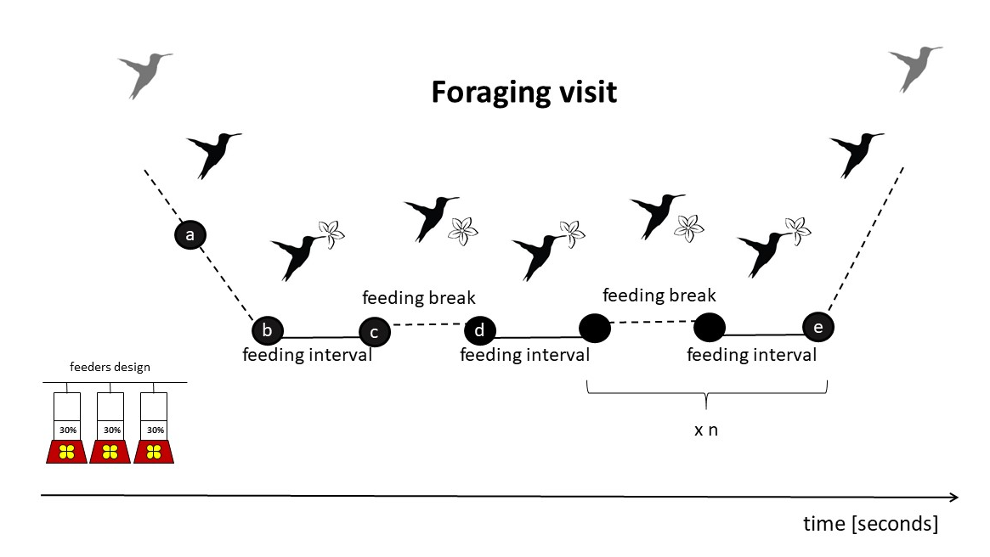

**Figure 2**. Repeatability estimates of foraging efficiency and behavioural parameters in the long billed hermit measured with linear mixed-effects models (Nakagawa & Schielzeth, 2010).

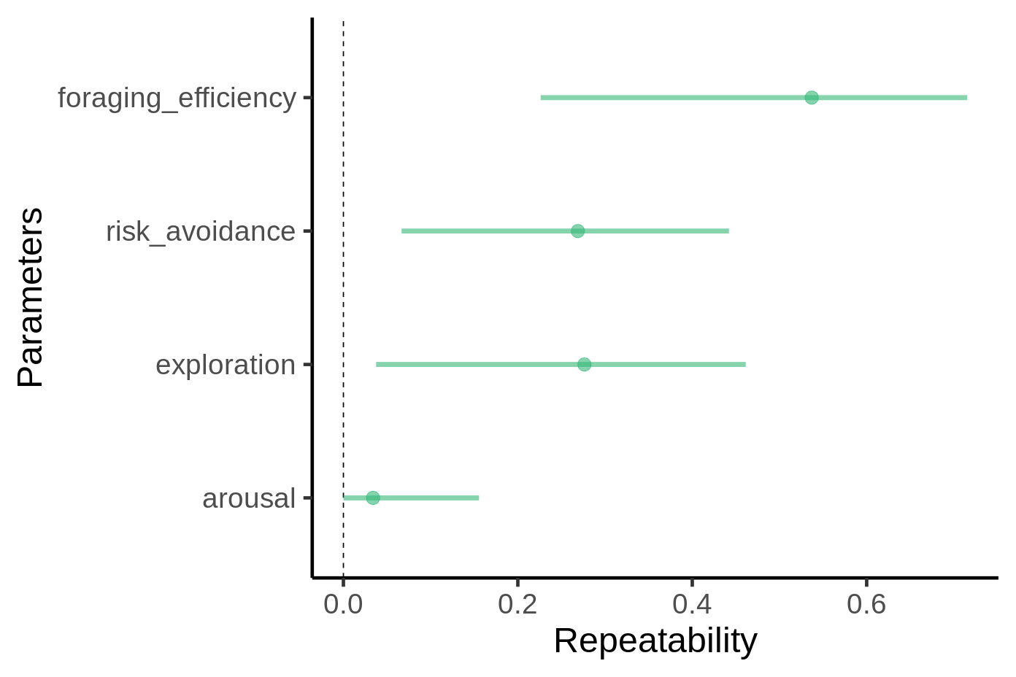

**Figure 3.** Foraging efficiency in the context of low and high levels of perceived risk of predation.

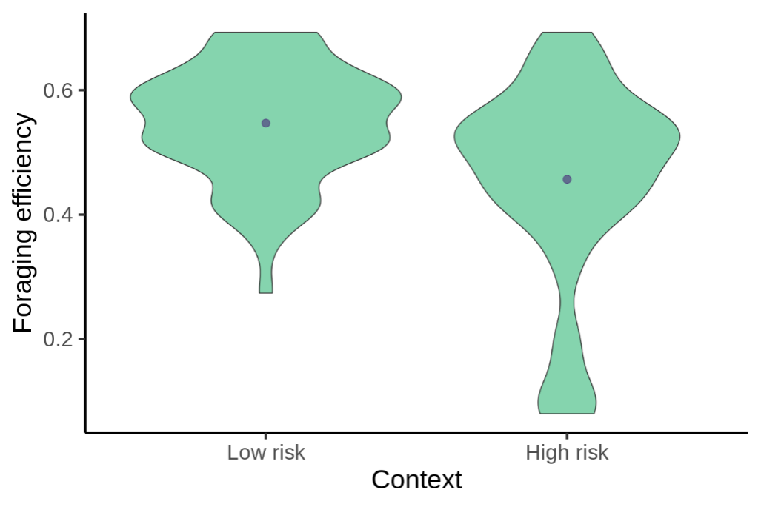

**Figure 4.** Foraging efficiency of long billed hermits in regard to their behavioural performance (exploration, risk avoidance and arousal) in the context of low and high levels of perceived risk of predation.

